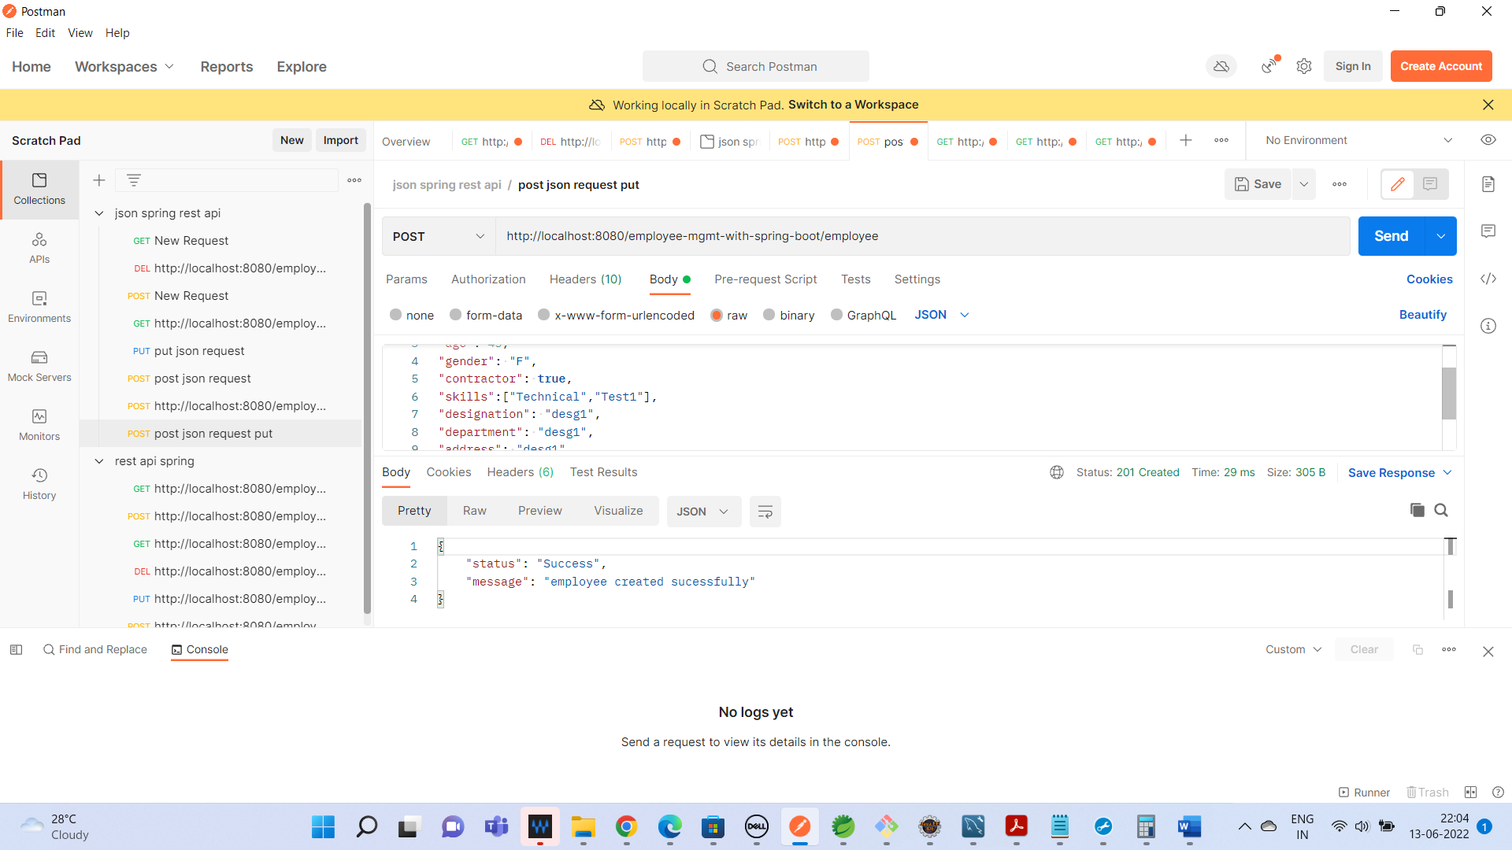

Employee payload

{

"name": "Jeffee22",

"age": 45,

"gender": "F",

"contractor": **true**,

"skills":["Technical","Test1"],

"designation": "desg1",

"department": "desg1",

"address": "desg1",

"country":"india",

"doj":"2020-08-09"

}

Endpoint is created with record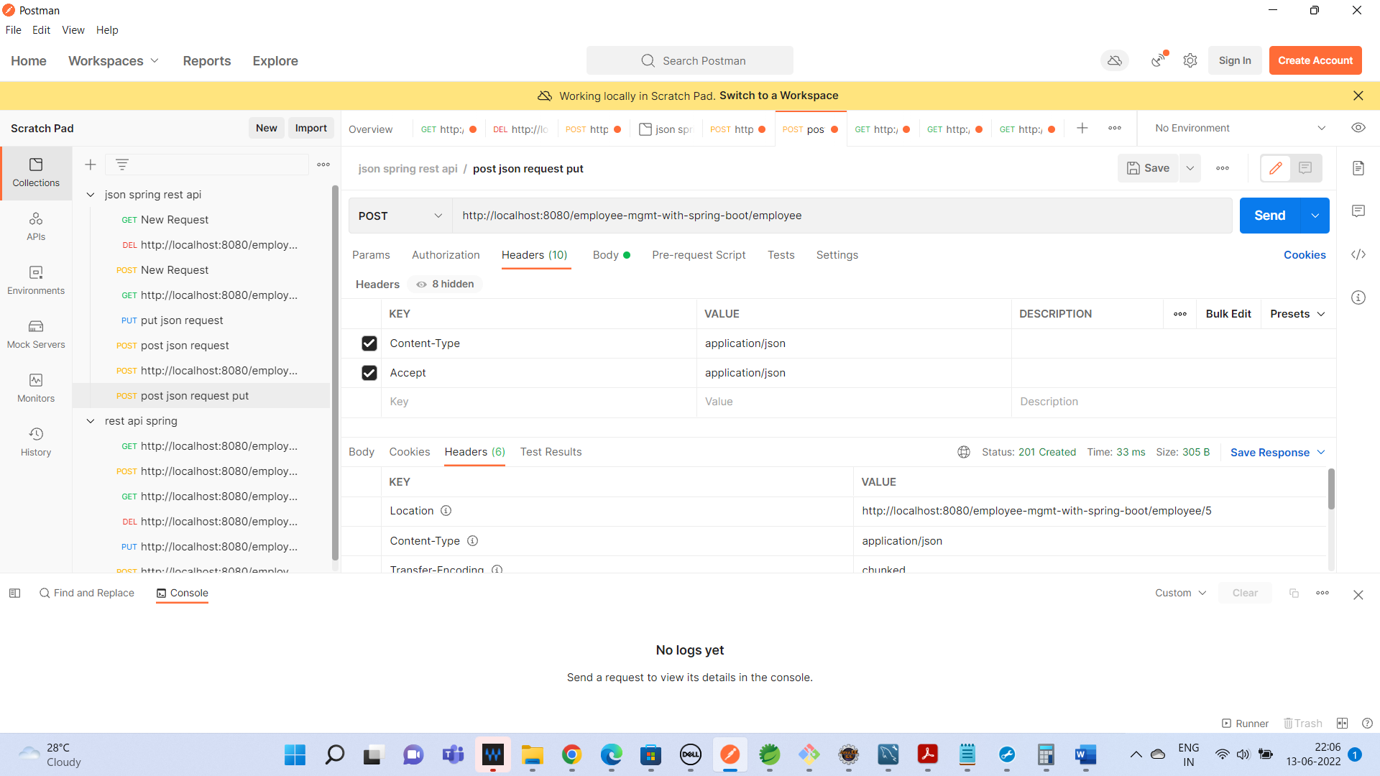

GET employee details:

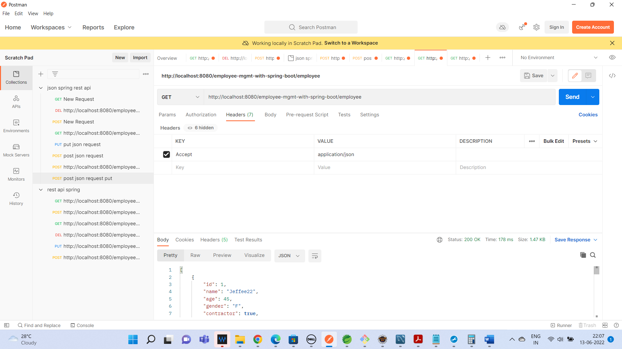

 "id": 1,

        "name": "Jeffee22",

        "age": 45,

        "gender": "F",

        "contractor": **true**,

        "skills": [

            "Technical",

            "Test1"

        ],

        "designation": "desg1",

        "department": "desg1",

        "address": "desg1",

        "country": "india",

        "doj": "2020-08-09",

        "createdTime": "2022-06-13T16:32:23",

        "modifiedTime": "2022-06-13T16:32:23"

    },

    {

        "id": 2,

        "name": "Jeffee22",

        "age": 45,

        "gender": "F",

        "contractor": **true**,

        "skills": [

            "Technical",

            "Test1"

        ],

        "designation": "desg1",

        "department": "desg1",

        "address": "desg1",

        "country": "india",

        "doj": "2020-08-09",

        "createdTime": "2022-06-13T16:34:22",

        "modifiedTime": "2022-06-13T16:34:22"

    },

    {

        "id": 3,

        "name": "Jeffee22",

        "age": 45,

        "gender": "F",

        "contractor": **true**,

        "skills": [

            "Technical",

            "Test1"

        ],

        "designation": "desg1",

        "department": "desg1",

        "address": "desg1",

        "country": "india",

        "doj": "2020-08-09",

        "createdTime": "2022-06-13T16:35:28",

        "modifiedTime": "2022-06-13T16:35:28"

    },

    {

        "id": 4,

        "name": "Jeffee22",

        "age": 45,

        "gender": "F",

        "contractor": **true**,

        "skills": [

            "Technical",

            "Test1"

        ],

        "designation": "desg1",

        "department": "desg1",

        "address": "desg1",

        "country": "india",

        "doj": "2020-08-09",

        "createdTime": "2022-06-13T16:35:42",

        "modifiedTime": "2022-06-13T16:35:42"

    },

    {

        "id": 5,

        "name": "Jeffee22",

        "age": 45,

        "gender": "F",

        "contractor": **true**,

        "skills": [

            "Technical",

            "Test1"

        ],

        "designation": "desg1",

        "department": "desg1",

        "address": "desg1",

        "country": "india",

        "doj": "2020-08-09",

        "createdTime": "2022-06-13T16:36:06",

        "modifiedTime": "2022-06-13T16:36:06"

    }

]

GET EMPLOYEE details by ID-2

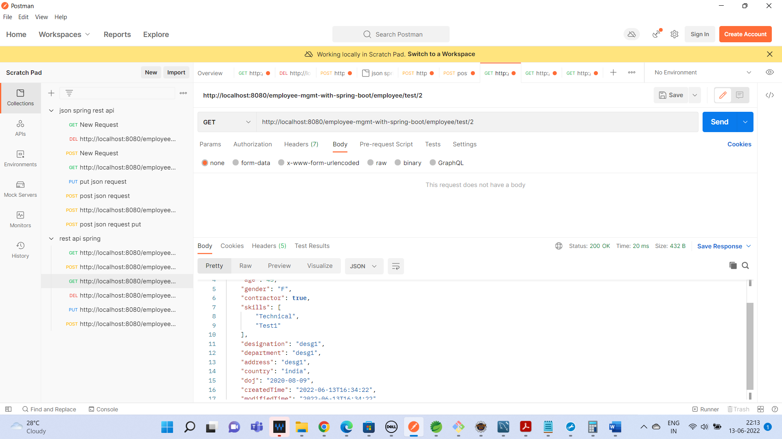

"id": 2,

    "name": "Jeffee22",

    "age": 45,

    "gender": "F",

    "contractor": **true**,

    "skills": [

        "Technical",

        "Test1"

    ],

    "designation": "desg1",

    "department": "desg1",

    "address": "desg1",

    "country": "india",

    "doj": "2020-08-09",

    "createdTime": "2022-06-13T16:34:22",

    "modifiedTime": "2022-06-13T16:34:22"

}

DELETE EMPLOYEE –ID 2 is getting deleted

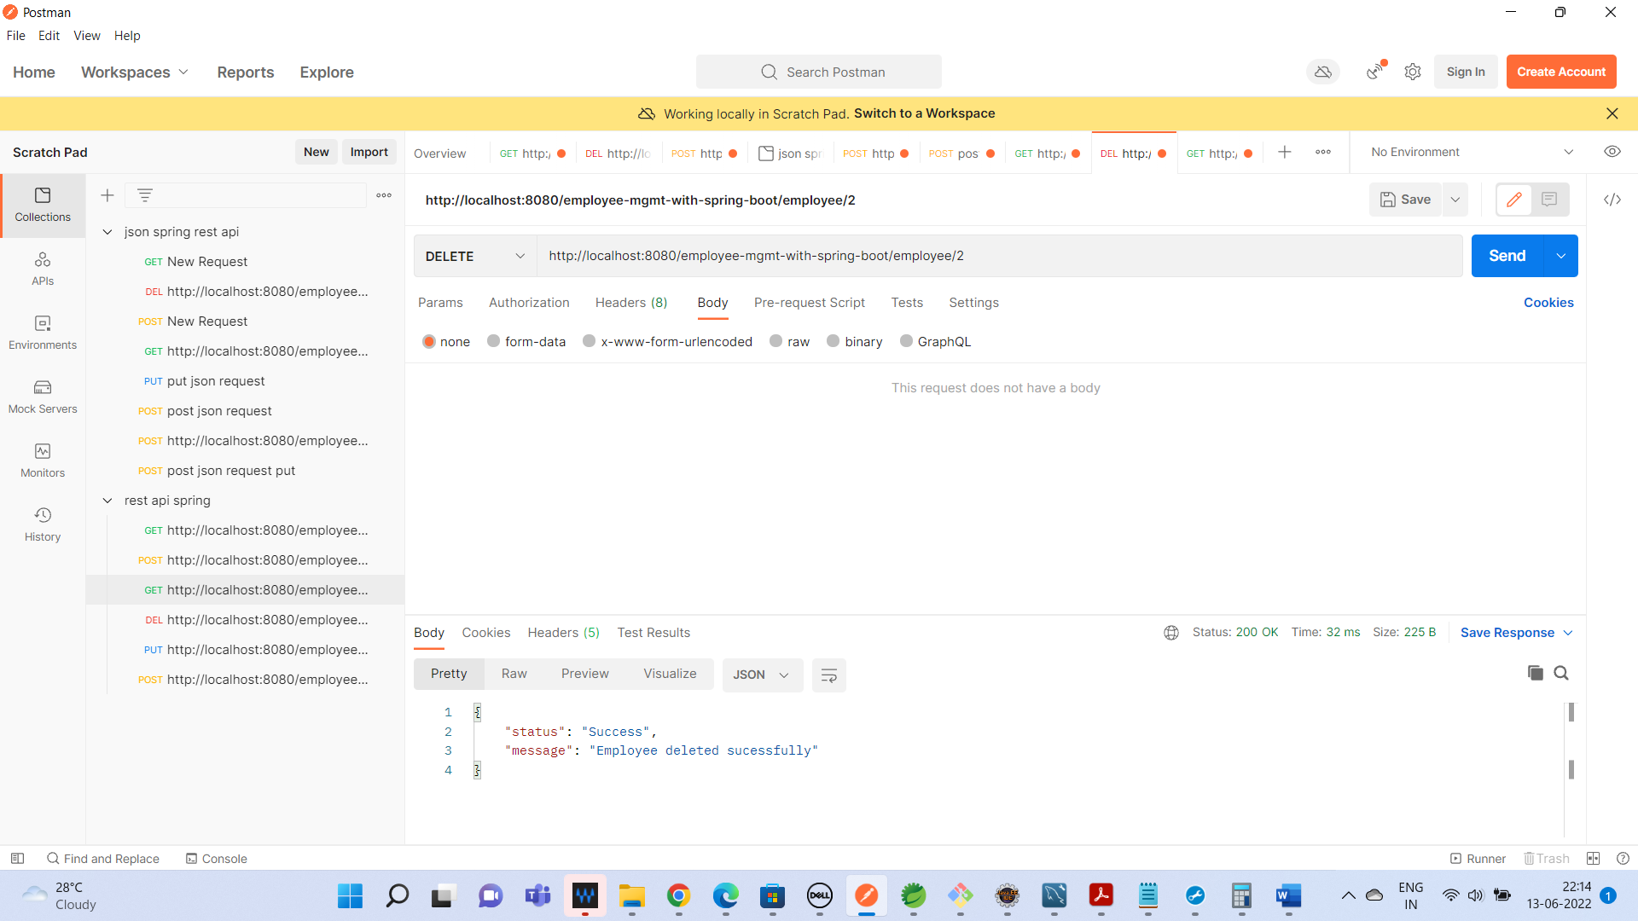

Searching for deleted employee

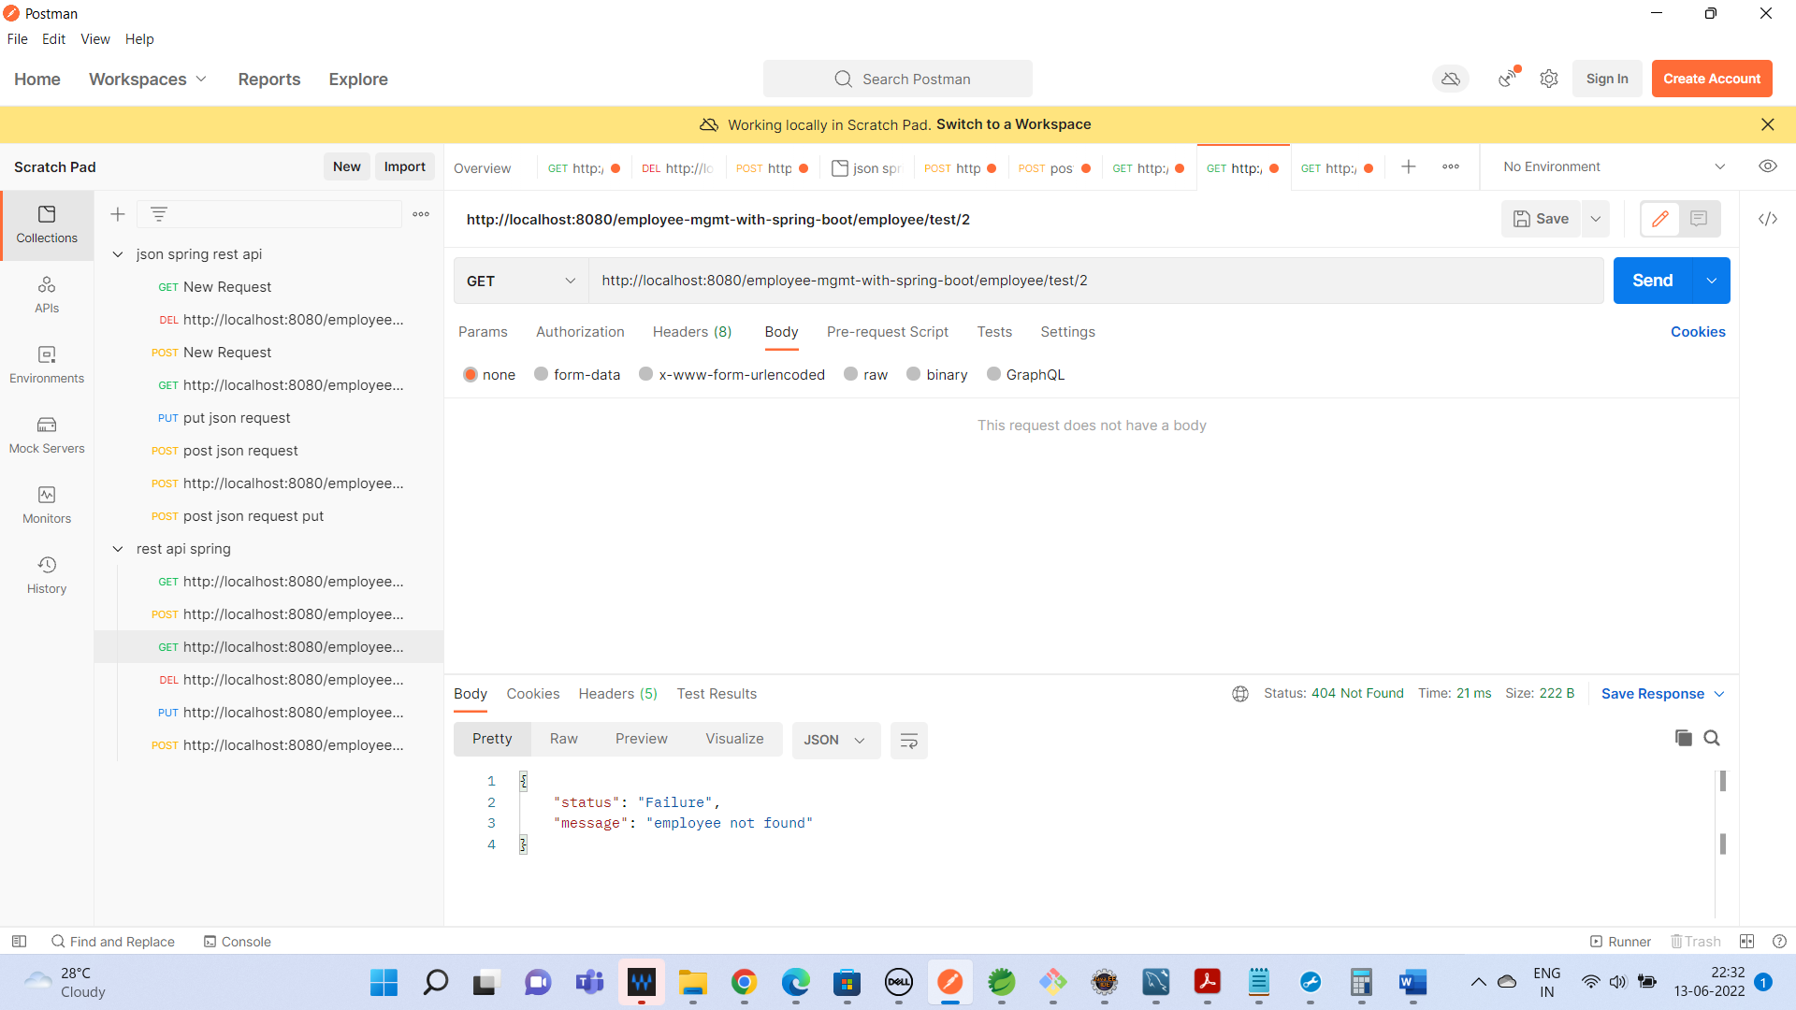

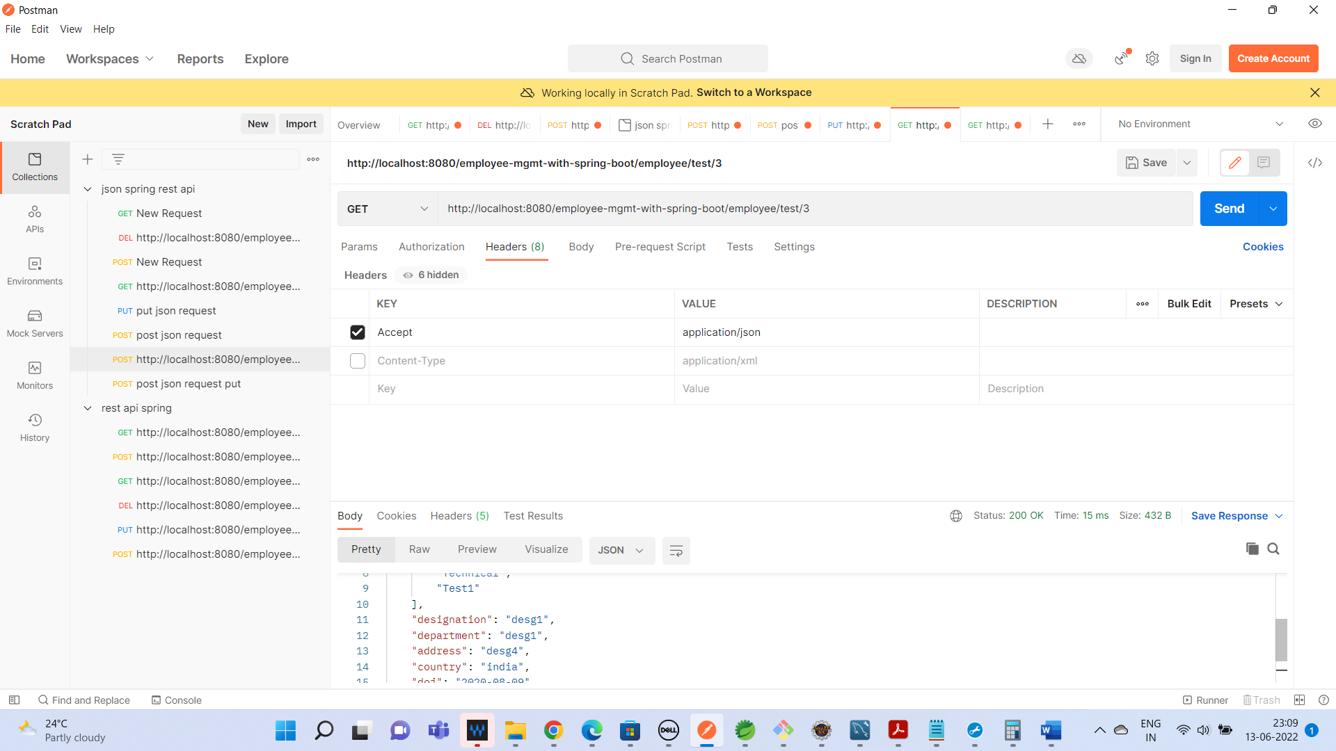

{

    "id": 3,

    "name": "Jeffee22",

    "age": 50,

    "gender": "F",

    "contractor": **true**,

    "skills": [

        "Technical",

        "Test1"

    ],

    "designation": "desg1",

    "department": "desg1",

    "address": "desg4",

    "country": "india",

    "doj": "2020-08-09",

    "createdTime": "2022-06-13T17:37:21",

    "modifiedTime": "2022-06-13T17:37:21"

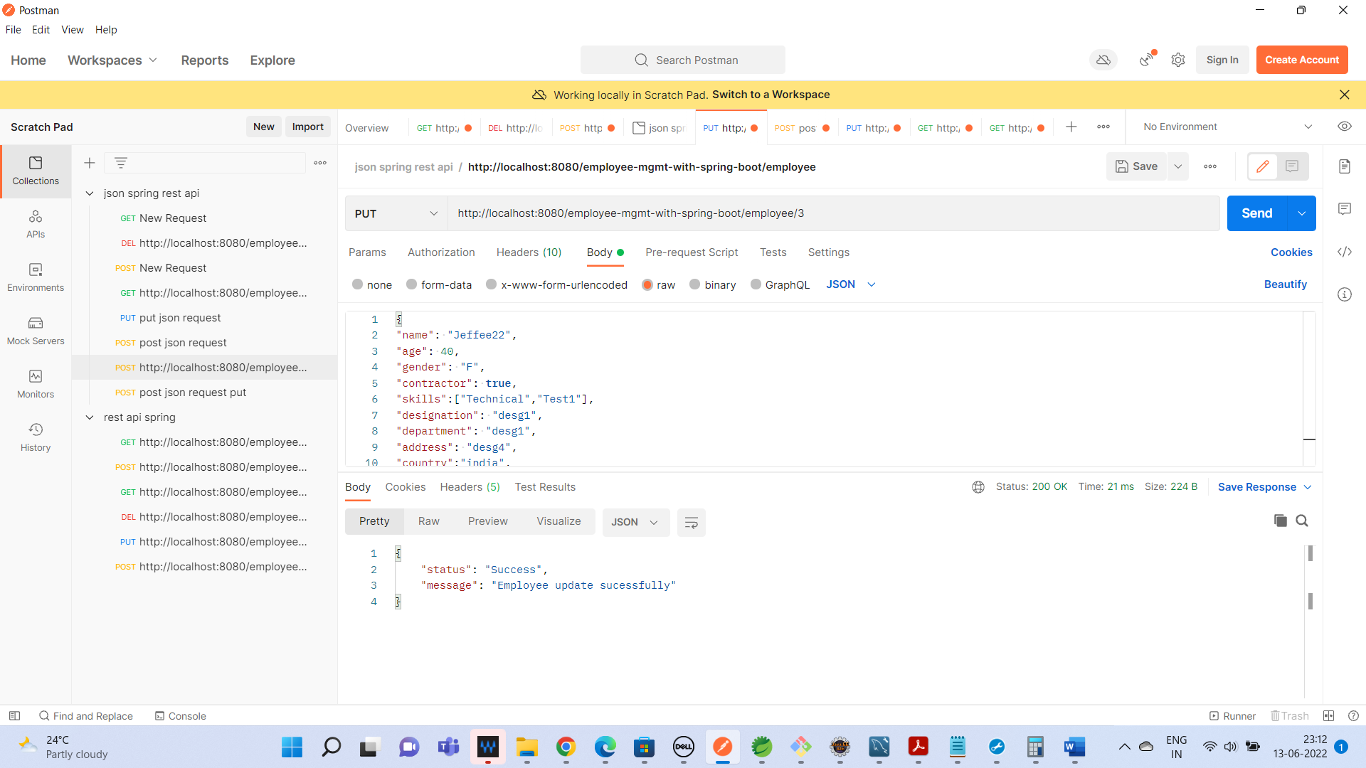

{

    "id": 3,

    "name": "Jeffee22",

    "age": 40,

    "gender": "F",

    "contractor": **true**,

    "skills": [

        "Technical",

        "Test1"

    ],

    "designation": "desg1",

    "department": "desg1",

    "address": "desg4",

    "country": "india",

    "doj": "2020-08-09",

    "createdTime": 2022-06-13T17:37:21,

    "modifiedTime": "2022-06-13T17:42:23"

}

Validation failure:Because name is blank

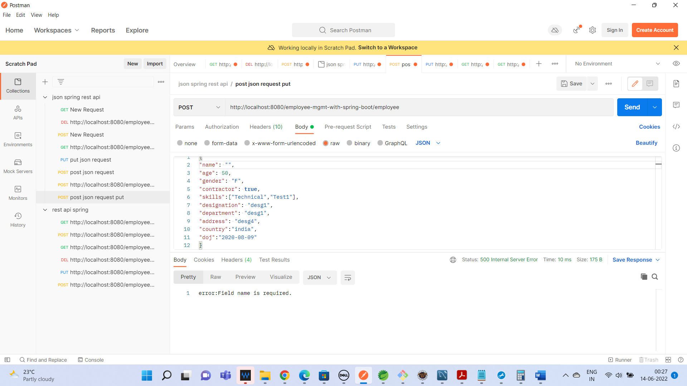

Actuator:

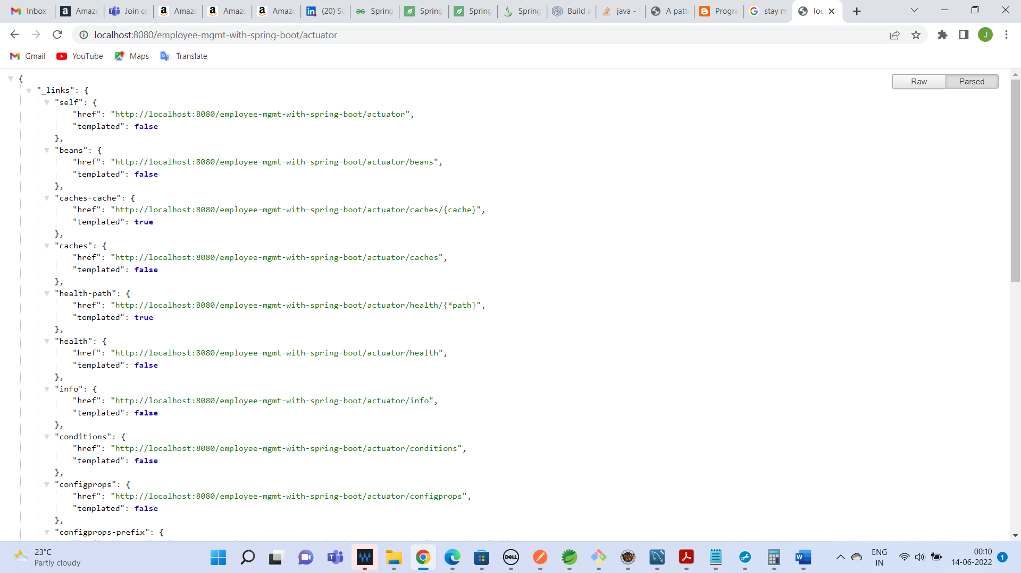

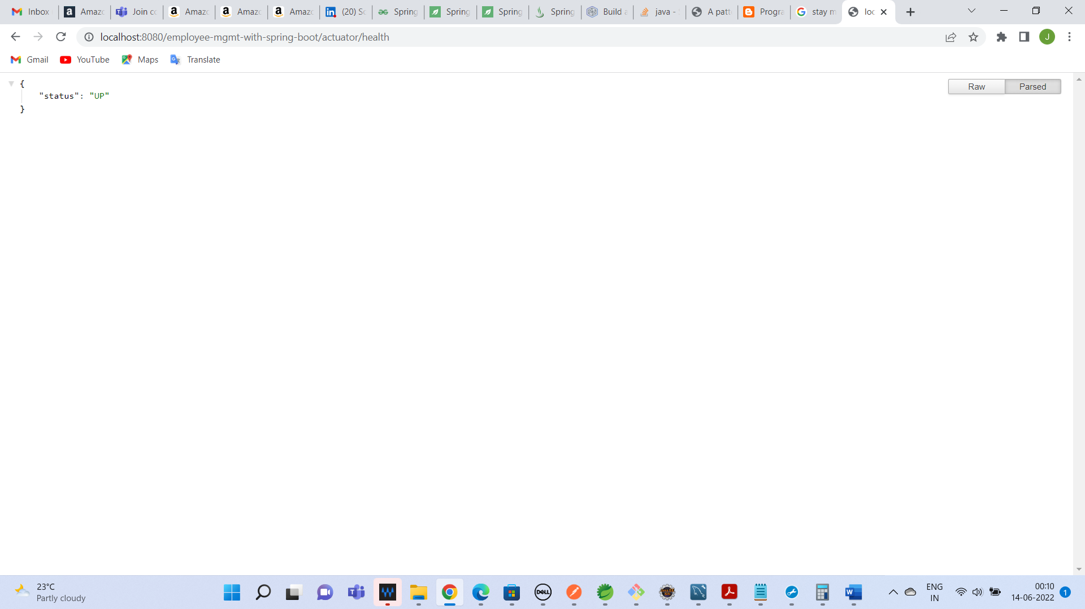

Content Negotiation with xml output

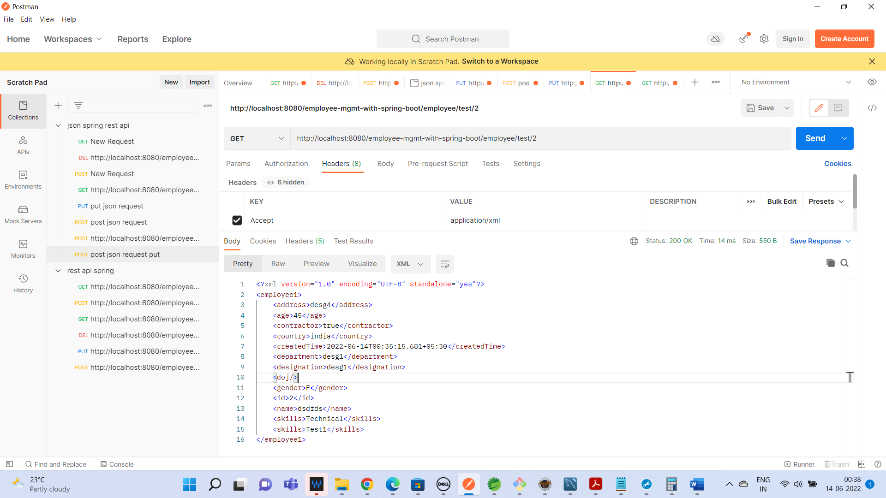

Profile

Currently active profile set to dev

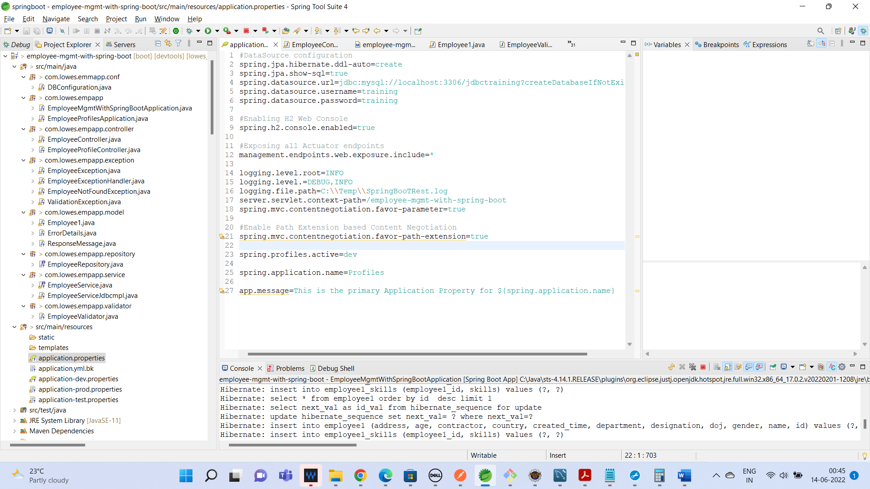

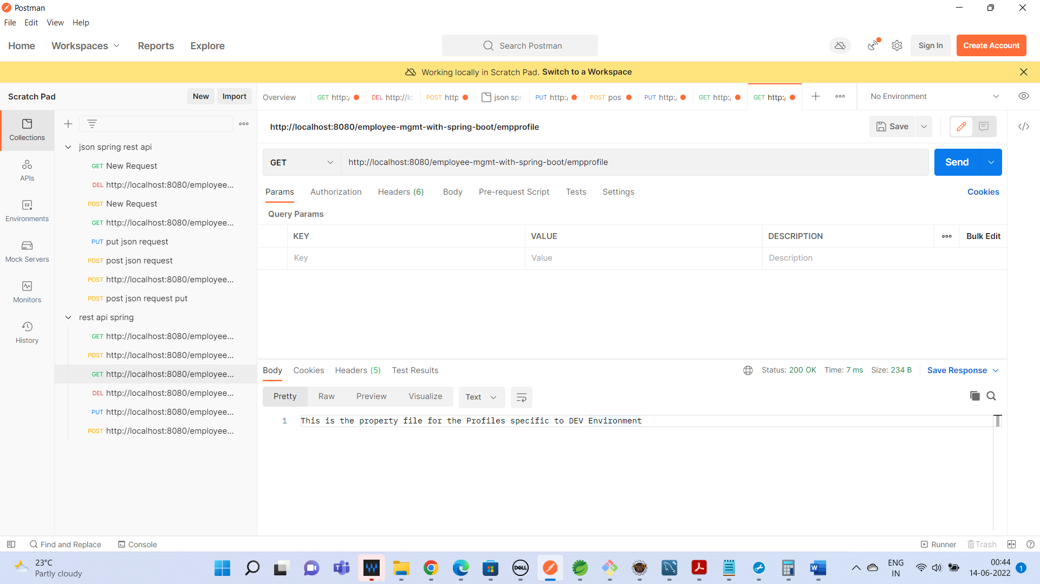

After changing the profile prod

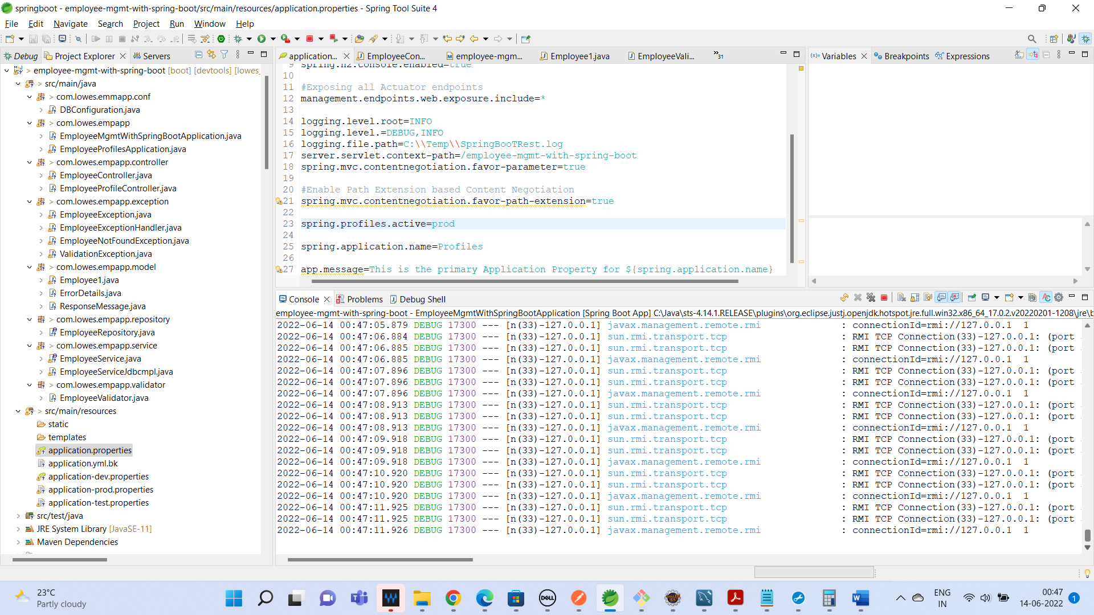

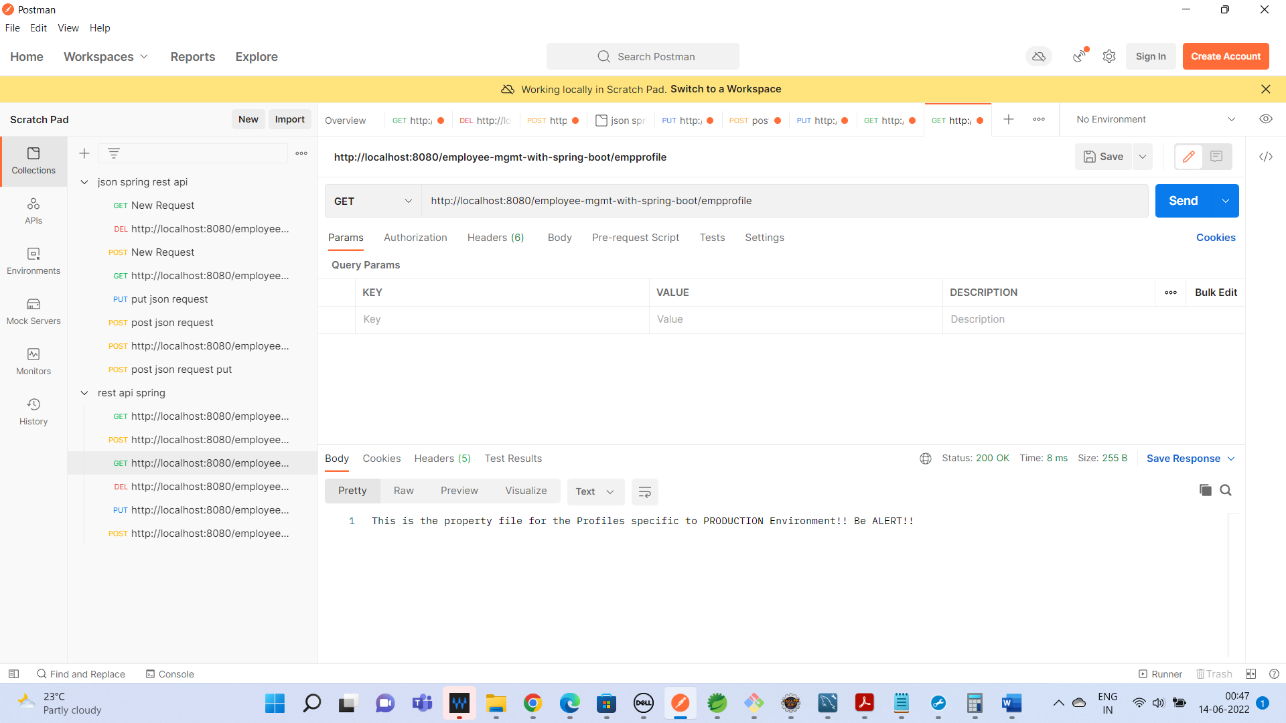

Application running from the command prompt

